Webiste Planning Document

Website name: cities Weather

Author: Rachel Huriavi

Site purpose: To inform people about the weather to tell people about weather warnings and a little bit more about these towns.

Target Audience: Anyone that is trying to find more information about the weather. This can be used on a mobile device. People who have money to spend on vacation in the cities listed. Also people who live in the cities of the site.

Site Map :

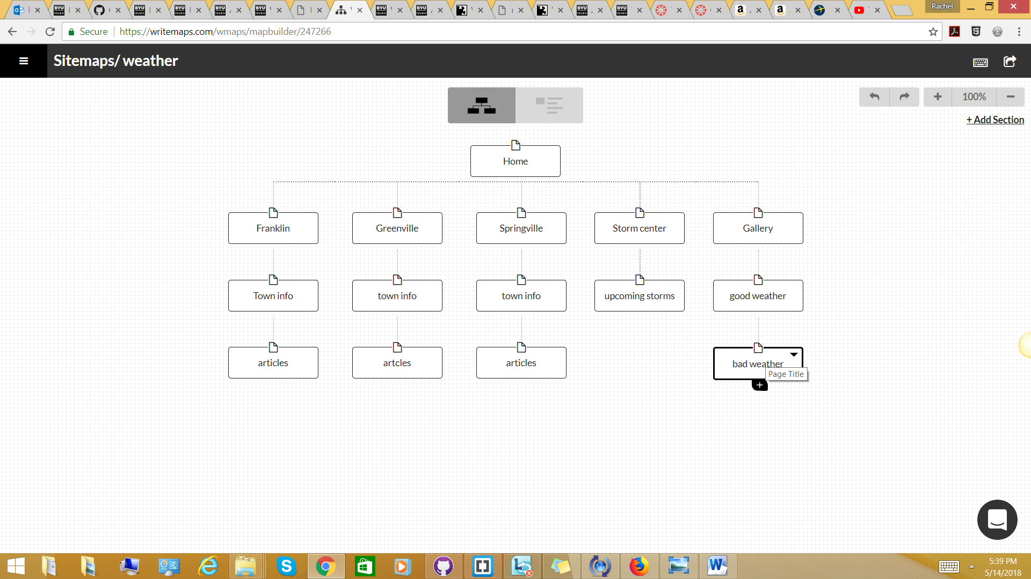

Color Scheme

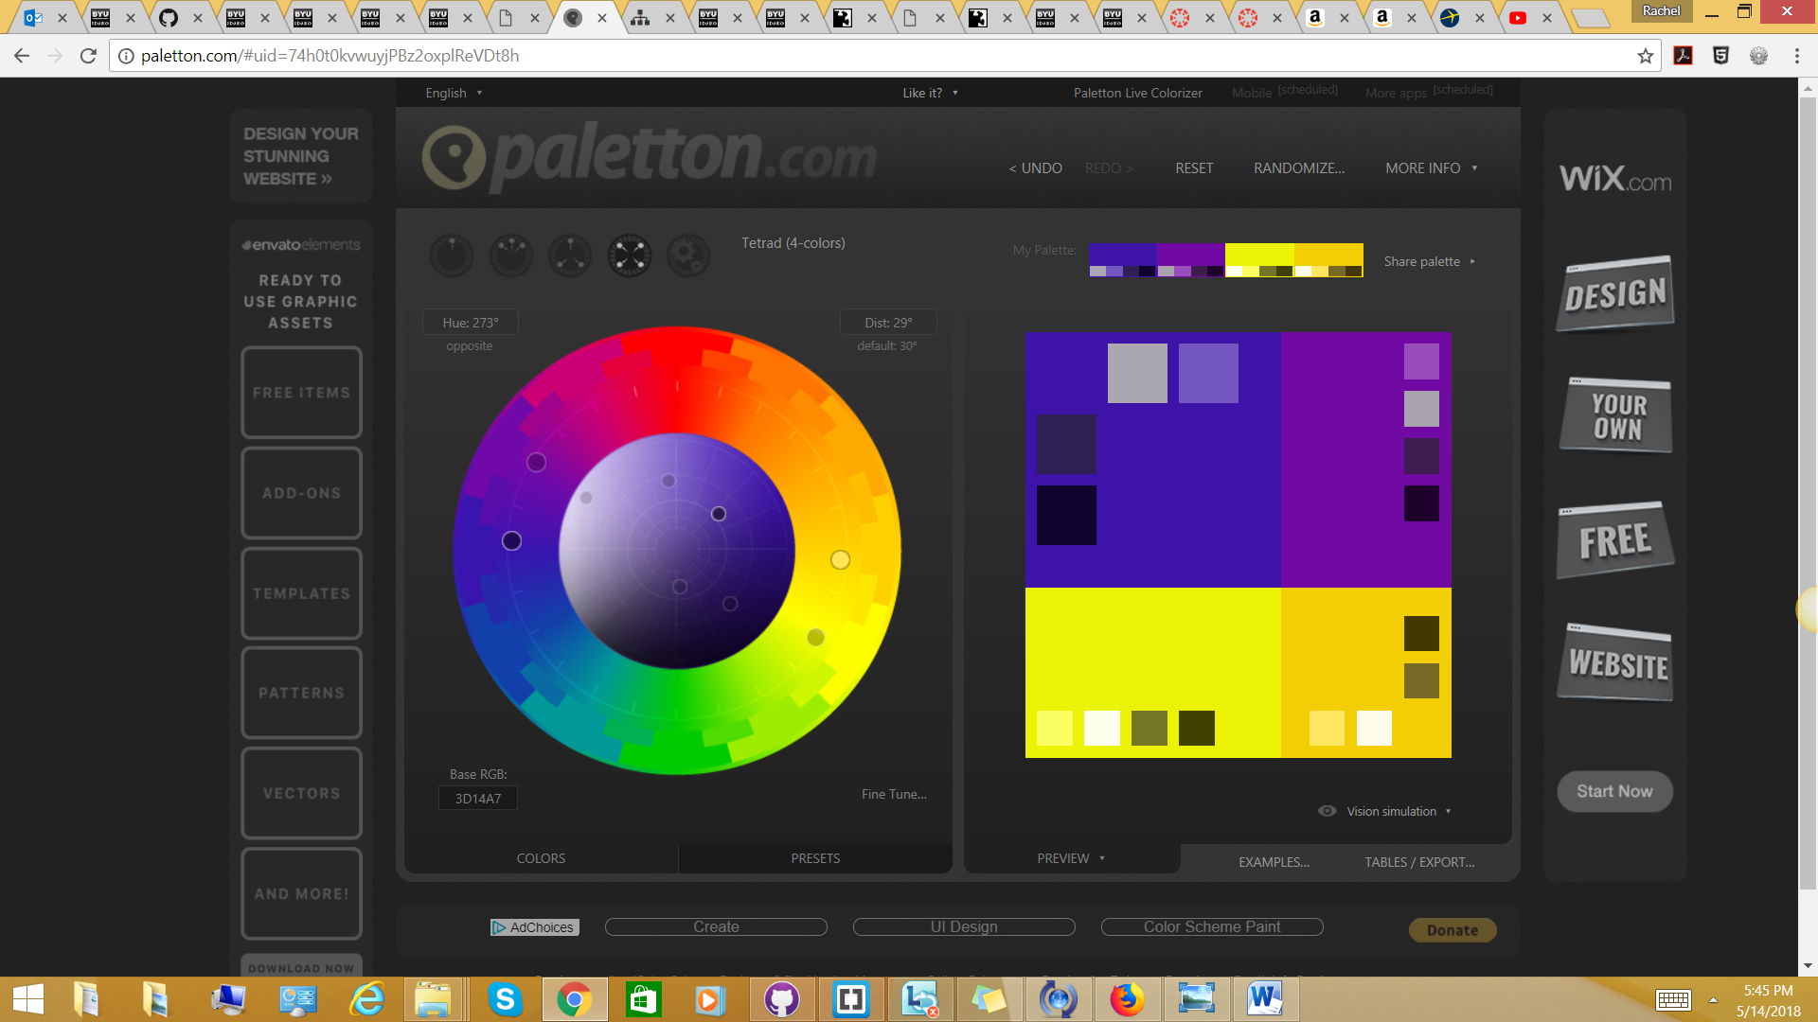

Background color:AAA7B2

Main color:4F19DC

Accent Color: 160B30

Accent Color: 765BBB

Accent Color: 2B2244

Typography

The fonts that I want to use are bookman arial and georgia next pro

|  |  |
| --- | --- |
| Site Header | georgia |
| navigation | georgia |
| Footer navigation | georgia |
| Headings | georgia |
| Paragraph | arial |

Wire-Frame Sketches

Small

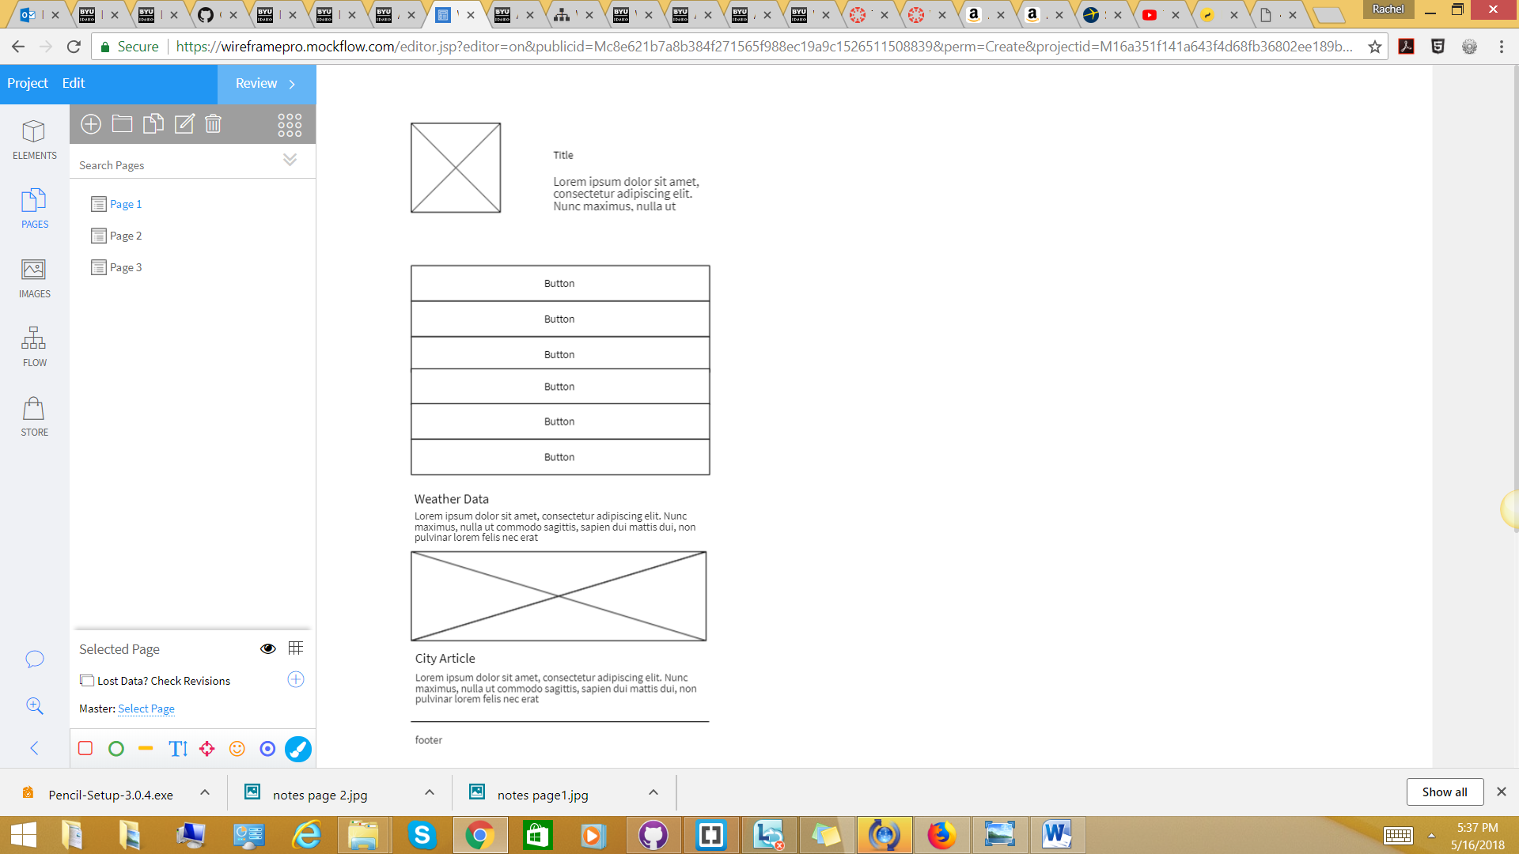

Medium

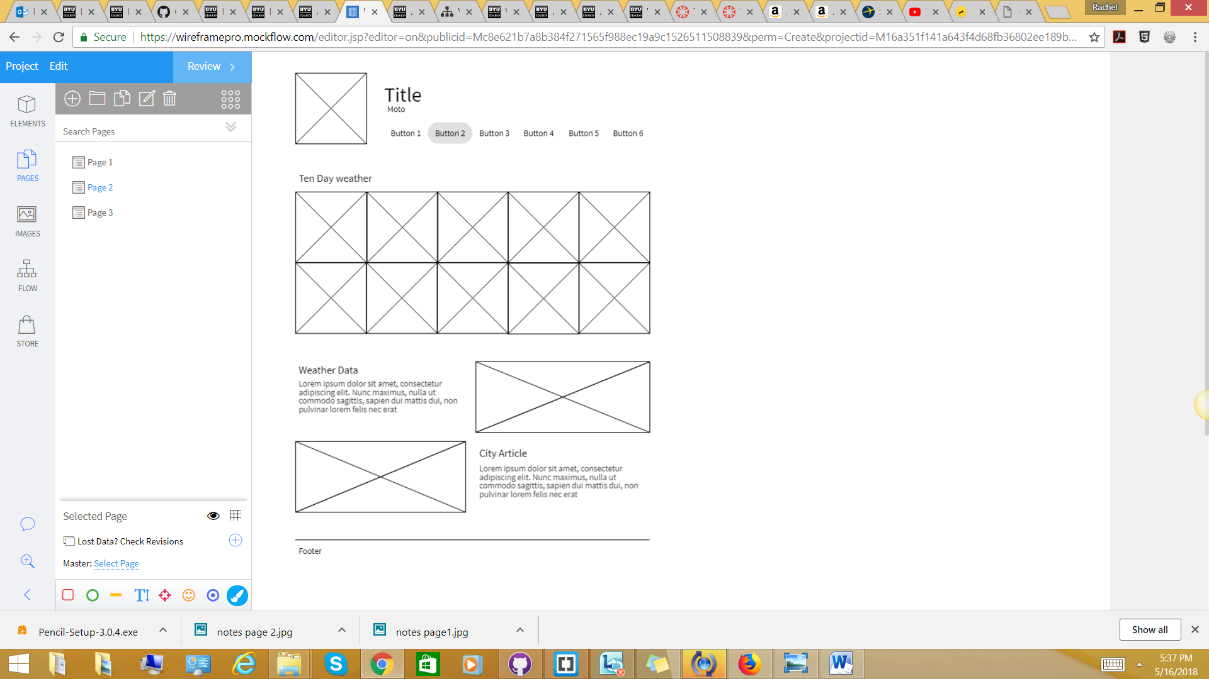

Large

